Voluntary recall of a selection of Kinder products
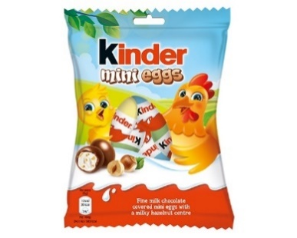
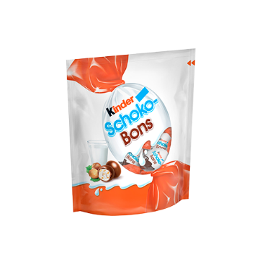
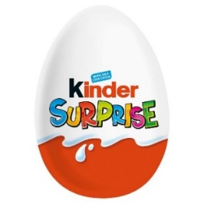
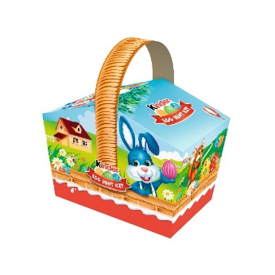
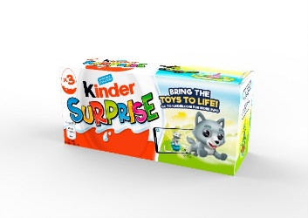
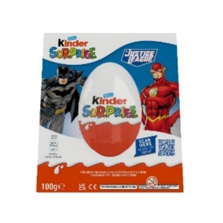
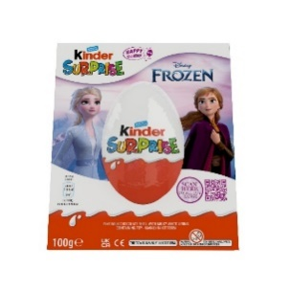

We are voluntarily recalling a selection of Kinder products, which have been manufactured in Belgium, as a precautionary measure, in relation to a number of reported cases of salmonella.
- Kinder Surprise 20g
- Kinder Surprise 20g x 3 multipack
- Kinder Surprise 100g
- Kinder Mini eggs 75g
- Kinder Egg Hunt Kit 150g
- Kinder Schokobons

What you should do
If you have bought one of the selected Kinder products as detailed above, do not eat it.
Instead:
- Contact the Ferrero consumer careline on consumers.uk@ferrero.com or consumers.ireland@ferrero.com to obtain a full refund.
- The toys included in these products are not affected
Want more information?
For more information, please contact us on:
UK:
consumers.uk@ferrero.com
0330 053 8943
Ireland:
consumers.ireland@ferrero.com
+44 (0)330 053 8943

